**TEST EVIDENCE – SPRING-45 – SPRING-HYSTERIX CIRCUIT BREAKER**

Dependency:

<dependency>  
 <groupId>org.springframework.cloud</groupId>  
 <artifactId>spring-cloud-starter-netflix-hystrix</artifactId>  
 <version>2.2.5.RELEASE</version>  
</dependency>

Annotation on main class:

@EnableHystrix

Annotation for method calling 2nd service api:

@HystrixCommand(fallbackMethod = "hysterixFallback")  
@GetMapping("/getmessagefromservice2Hysterix")  
public String loadMessageFromService2WithHysterix() {  
 *log*.info("calling service 2 /message api");  
 String msg= restTemplate.getForObject(  
 "http://localhost:9011/service2/message/",  
 String.class  
 );  
 return msg;  
}  
  
public String hysterixFallback(){  
 return "service 2 is down please try after some time";  
}

API CALLS WHEN APPLICATION IS UP:

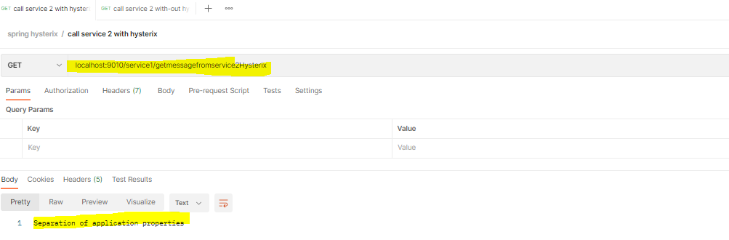

API CALL WHEN APPLICATION IS DOWN:

